

38 & 40 Bont Bridd, 6 Stryd Llyn and 34 High street, Caernarfon.

Technical and Commercial Questionnaire

You must also complete the Qualification Questionnaire if you want your bid to be evaluated.

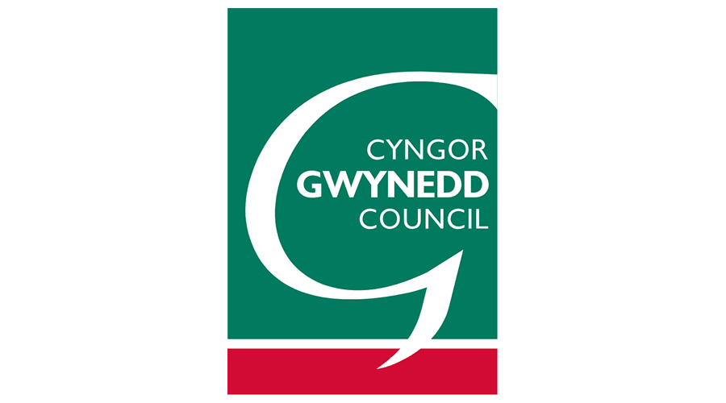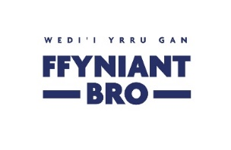

1 | This Question accounts for 50% of the Quality Section and 35% of the overall score of the tender. You may attach the answer to this question on a separate document, as long as it is clearly labelled. | Q1. Please provide a brief description of up to 5 relevant commissions you have successfully delivered in the last 10 years in respect of works centred on retail properties in Wales that demonstrate your experience of working in the field of adapting retail properties with accommodation on upper floors. Please provide references to support from previous clients. Please provide a portfolio of previous work. If you are bidding on behalf of a consortium, please provide examples from the consortium member(s) which would deliver each relevant part of the requirements if you were successful.
 | Commercial Envelope
 | Supplier Guidance | Question | Answer
* | This envelope carries a weighting of 70% of your overall score. | Please complete the form of tender included as part of this tender package.

2 | This Question accounts for 50% of the Quality Section and 35% of the overall score of the tender. You may attach the answer to this question on a separate document, as long as it is clearly labelled. | Q2. Please detail on how you would propose to deliver the services outlined in the brief to the complete satisfaction of the client. Your answer should include reference to key personnel that would be working on the project and your company’s capacity and resources. Your response time in attending site is important as is your travel distance with a view to availability and carbon footprint. Providing a bilingual service in Welsh and English is beneficial. Please also outline any steps you have taken to provide local community benefit in the past.

